Project Documentation

# 1. Introduction

Project Title: FITFLEX

Team ID: [NM2025TMID28778]

Team Leader: [SANTHIYA.K, [santhiyak626@gmail.com](mailto:santhiyak626@gmail.com)]

Team Members: [KAVIYA.M , [kaviyamahendran00@gmail.com](mailto:kaviyamahendran00@gmail.com)],

, :[AARTHI.D, [aarthidhanabal68@gmail.com](mailto:aarthidhanabal68@gmail.com)],

:[SANGEETHA.S, [sangeethamizh38@gmail.com](mailto:sangeethamizh38@gmail.com)]

# 2. Project Overview

Purpose: A fitness-oriented frontend application that helps users explore exercises, equipment categories, and workout guidance with an interactive UI.

Features:

- Landing/Home Page with hero section

- Exercise search and filter by category/equipment

- Informational About section

- Reusable components for navigation, footer, and hero

- Responsive styling with custom CSS

# 3. Architecture

Frontend: React.js with custom CSS

Backend: Not included (Frontend-only project)

Database: Not included (Data may come from APIs in future integration)

# 4. Setup Instructions

Prerequisites: Node.js, npm, Visual Studio Code (recommended)

Installation Steps:

git clone <repo-url>

cd code

npm install

npm start

# 5. Folder Structure

code/

|-- public/ # Static files (index.html, icons, manifest)

|-- src/ # Source code

| |-- assets/ # Images & media

| |-- components/ # Reusable React components

| |-- pages/ # Page-level components

| |-- styles/ # CSS styling

| |-- App.js # Root app component

| |-- index.js # Entry point

|-- package.json # Project dependencies

|-- README.md # Basic info

# 6. Running the Application

cd code

npm start

Access the app at http://localhost:3000

# 7. API Documentation

Future integration may include:

- Exercise APIs

- Authentication APIs

# 8. Authentication

Not implemented in current version.

Can be extended with JWT or OAuth in future.

# 9. User Interface

- Landing Page (Hero, Search, Categories)

- Exercise Page (view by body part/equipment)

- About Page (project info)

- Navigation bar & Footer (common layout components)

# 10. Testing

Manual Testing: Browser-based testing during development

Tools: Chrome Dev Tools, React Testing Library (setup included in App.test.js and setupTests.js)

# 11. Screenshots or Demo

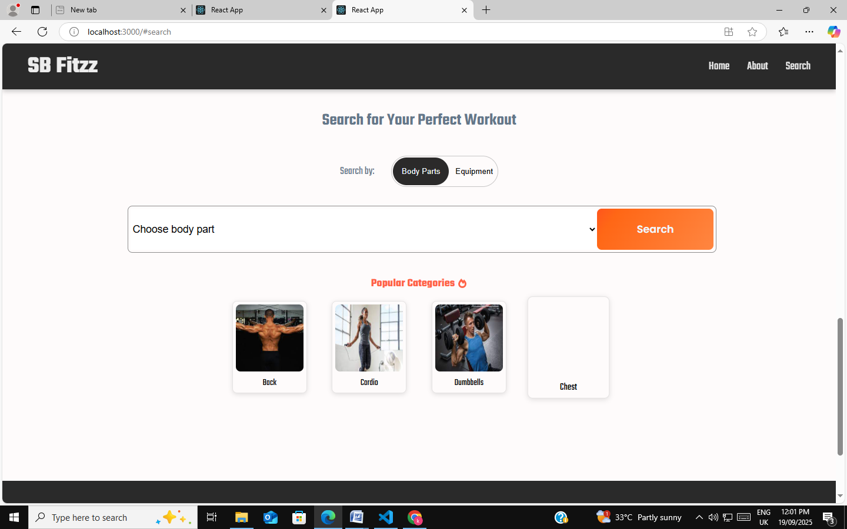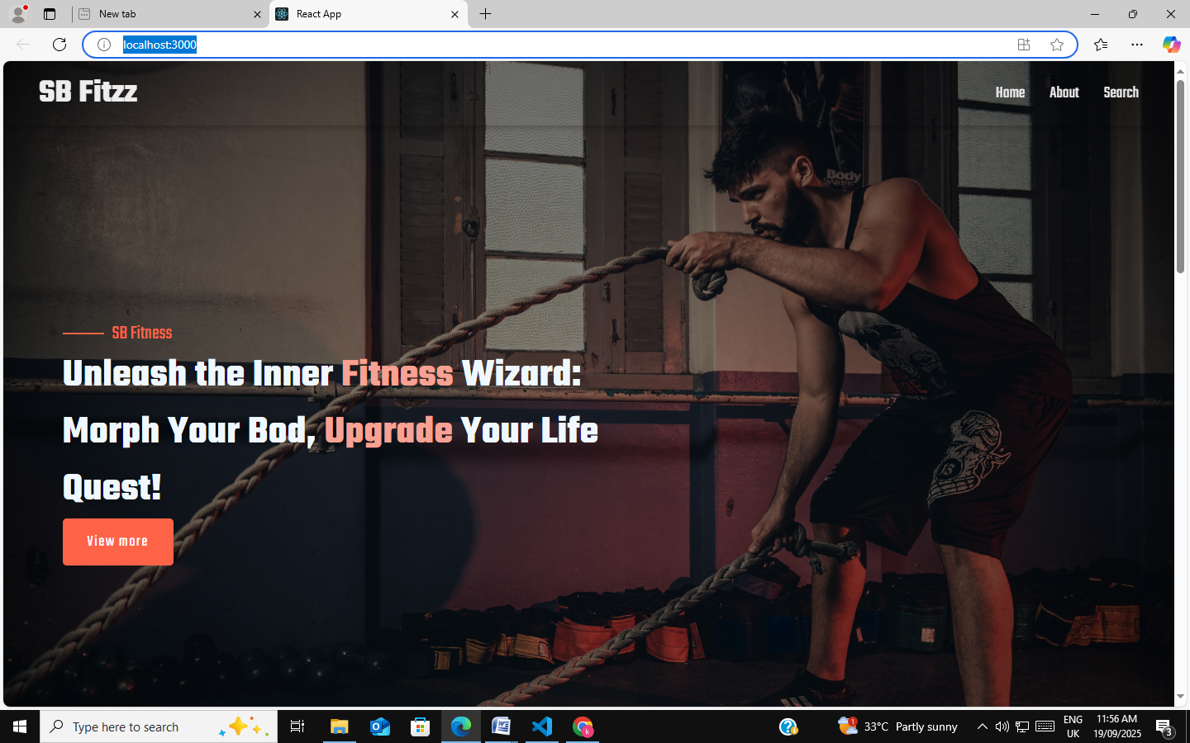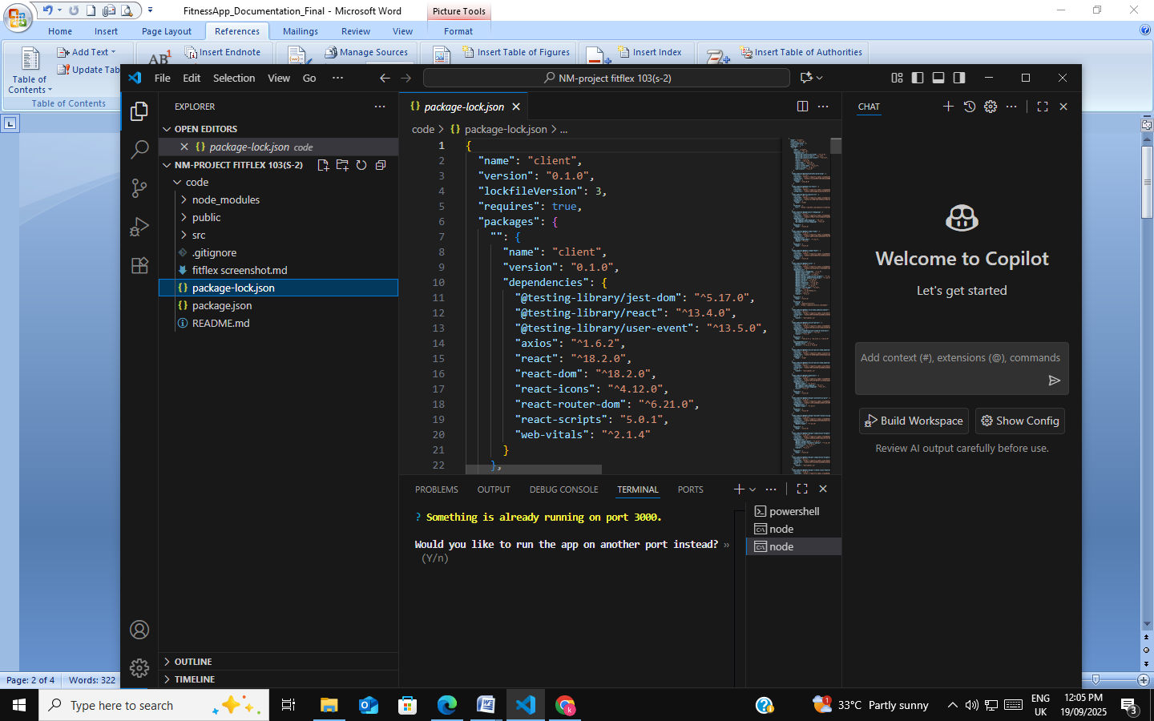

# 12. Known Issues

No backend/API integration yet

Limited dataset for exercises (static frontend)

# 13. Future Enhancements

Integrate external Exercise APIs

Add authentication (JWT-based login/signup)

Implement state management (Redux or Context API)

Make responsive improvements for mobile